Costa Rica Quiz: Qué sabes (What do you know?)
Name ______________________

- Where is Costa Rica located:
- Name the capital of Costa Rica we will be arriving into:
- Name the city we will be flying out of:
- Name a famous food dish of C. Rica:
- How would you translate “plátanos”
- Name an expression Costa Ricans say a lot:
- What term in Spanish do they use to refer to Costa Ricans:
- Name the Organic Farm we will be visiting:
- Name a famous animal we will probably be seeing in C. Rica?
- What day of our itinerary will we be visiting Caño Negro?
- What is the name of the volcano we will be visiting and staying near:
- What is the Costa Rican money called?
- How much is it worth approximately to the dollar?
- What is the name of the place we will be doing our kayak tour?
- What is the name of the waterfall?
- What is the name of the hot springs we will be staying near and visiting?
- How many micro-climates are there in C. Rica?
- Name the beach we will stay at our last 2 days:
- What is a special type of eco-system that will be kayaking through?
- Tie Breaker: What year did Costa Rica gain independence from Spain?
  - 1845 b. 1821 c. 1904

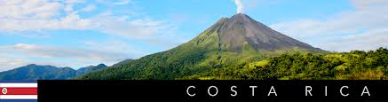

For each correct answer give yourself 1 point.
Total score: _________

